**Geovisualization of artificial land use in European cities in 2006, with urban scaling laws**

**Axel PECHERIC**

University of Rouen, IDEES Laboratory UMR 6266 CNRS, Mont-Saint-Aignan, France.

Rémi LEMOY

University of Rouen, IDEES Laboratory UMR 6266 CNRS, Mont-Saint-Aignan, France.

Marion LE TEXIER

University Paul Valery Montpellier 3, LAGAM, Montpellier, France.

**Introduction**

More and more people live in cities, almost 80% of the European population lives in urban areas (European Environment Agency, 2006), resulting in continued growth of urban areas. Current urbanization tends to consume a lot of space (suburban areas, business parks), combined with strong de-densification in rural areas (less attractive), which leads to a significant increase in soil artificialization on the outskirts of large cities.

The constant growth of cities reveals sustainability issues in the housing and transport sectors by challenging the spatial organization of cities, for example by increasing travel times and car use. Humanity is facing major climate change, a depletion or even exhaustion of various non-renewable resources, and a concentration of socio-economic inequalities and pollution (especially air pollution) in urban areas, which are also nodes for the spread of epidemics and have an urban heat island effect (EEA, 2010). Cities are growing in terms of population, and even more so in terms of artificial land use through the phenomenon of urban sprawl and building densification. Urban sprawl is increasing around both growing and shrinking cities. The land consumed by urban sprawl is often outside the administrative areas of cities and it is almost always irreversible. The desire to have a more sustainable management of urban space, for example by reducing the artificial land use, have been at the heart of urban development policies for decades now.

A new science of cities has emerged with the urban scaling laws (Bettencourt, 2013). Urban scaling laws (which allow to transform a set of objects from one spatial scale to another without changing their structure) prove themselves to be a great tool to compare cities (Batty, 2015). A major consequence that leads to rescaling is that these systems evolve and develop from the bottom up (cities are small before they become large). The size and shape of cities follow urban scaling laws that result from strong competition for space.

In 1969, Tobler states that the built-up area of an agglomeration is proportional to the population with an exponent of 0.44 for the radius scale, but with less detailed and less provided data. It is quite close to 0.5 for the results presented in this application. With the increased availability of data and the more powerful technical means, it is now possible to verify these claims and results.

Nordbeck (1971) shows that cities have the same shape regardless of their size by studying areas and populations. However, he does not empirically study the internal structure of cities.

Scientific research is very empirical and focuses on how different aggregate variables describing the socio-economic or physical state of cities evolve with the city's population (Louf and Barthélémy, 2014). The internal structure of cities follows a homothetic scaling relationship with respect to population (Delloye, Lemoy and Caruso, 2021). While the spatial heterogeneity or internal structure of cities is little considered in literature. Another goal is to bring together intra-urban and inter-urban analysis in urban scaling laws.

Through the work of Lemoy and Caruso (2018), comparison becomes possible for cities of different sizes and geography makes it possible to provide spatial comparability of territories (thanks to rescaling).

The definition of the city is crucial. Indeed, the collection of data and the lack of a clear definition of cities on a global scale create problems for the in-depth analysis of these urban systems. For example, it is problematic for the fine distribution of the population if the delimitations are not the same in all countries. Furthermore, the scale exponents are very sensitive to the definition of the city and this can lead to different conclusions. The scale relationships found by Lemoy and Caruso allow for new and more consistent definitions for cities of all sizes, using the land use scale as a reference.

The methodological choice behind this work is the use of radial analysis to describe the cities. The radial analysis allows the complete distribution of land and people in the city. This is based on Alonso's model, the city is considered as circular and monocentric. The reference center for the city corresponds to the city hall in each case.

The city does not only represent the urban core, but the peripheral spaces must also be considered in the analysis of urban scaling laws (and thus the whole urban environment is considered). The city is studied morphologically, focusing on the organization of the succession of land uses. Using a distance-based approach allows us to better grasp the phenomenon of urban sprawl and how to better control it.

Geovisualization, which brings together "knowledge and techniques for visualizing a territory by interacting with the user's perception and cognition capacities" (Sidonie Christophe) is a fabulous way to use our geographical data. This makes it possible to create graphical representations to help the user better visualize and perceive spatio-temporal phenomena more quickly, particularly through interactive choices. Data analysis and representation is a major challenge when dealing with large datasets, moving from raw data to data for information. Communicating research through interactive visualization (better ownership of the information) is becoming a major goal for researchers.

1. **Presentation of the application**

This web application presented here focuses on artificial land use in 2006 with urban scaling laws, in 305 European urban areas with more than 100,000 inhabitants, described by harmonized land use databases. We use the Copernicus Urban Atlas 2006 land use database at 5 m resolution and the Geostat population grid at 1 km resolution. Artificial land use refers to all land use categories in the Urban Atlas except water areas, agricultural spaces, urban green spaces and forests.

The objective is to analyze how the urban structure (more specifically land uses) changes with distance from the main center. The approach of this work concerns both inter- and intra-urban scales with an urban center-periphery analysis, which constitutes the first spatial differentiation for urban areas (Guérois and Pumain, 2008), widely studied in economics at the theoretical level by the Alonso model. The main result of this work is that the organization of land use successions occurs at the same rate if we cancel out the size effect of urban areas on a European scale (Lemoy, 2020). The aim is to facilitate the understanding of this theme and to obtain a more sustainable management of territories in the future.

Each city is rescaled by a factor that is obtained by dividing the population of London by the study city, all to the square root. London being the European city with the largest population in Europe, it is chosen as the reference city for the rescaling factor (k):

$$k= \sqrt{\frac{N_{London}}{N}}$$

where N is the population of the city being analyzed and $N_{London}$ is the population of the largest city in the dataset.

The choice of the central point for the analyses is the location of the city hall in the historic center, this corresponds to the artificialized areas near the high population densities. Then, concentric rings of 141 m (100√2) are made around the city hall in order to calculate the share of land use in these rings. The artificial area around the city center scales linearly with the population of the urban area.

This web application was developed using the Shiny package of R to favour interactivity and is primarily designed for land use planning actors. However, in the long run, it will be accessible to everyone once put online on the Internet. The R language is well suited to the use of interactive cartography. It is very useful for statistical and cartographic representations. To make this tool more attractive, it must be fun and easy to use for those involved in spatial planning. The application can be described as an intuitive analysis interface thanks to the R Shiny language which is an open-source technology and can allow the application to be displayed on a browser, making it accessible to a wide audience through geovisualization (Keim and al, 2008).

One of the initial objectives in creating the application was to find the most satisfactory solution for the user. In particular, by means of interactivity and by transforming the information overload into clear and readable information for the user. It is also important not to have too many interfaces in order not to lose or distract the user (Smith D, 2017).

The application is organized in several tabs: Interactive map (figure 1), Methodology (to go deeper into urban scaling laws and the datasets), European examples (to see cities before and after rescaling with graphs and maps on typical cities), France versus Spain (to see differences on urban fabric, industries and roads land use), "And my city, how does it stand?" (statistical and cartographic comparisons of the cities selected by the user).

Thematic tabs allow the user to move easily from one visualisation tool to another and to access specific methodological descriptions. The application has been designed as a "step-by-step" application, starting with the discovery of the interactive map and ending with the visualization of similar European cities according to the city chosen by the user.

1. **Home and methodology tab**

The interactive map at the beginning of the application (figure 1) allows to have a global vision on a European scale thanks to the 2 base maps and the possibility to display the French EPCIs and European FUAs. Circles represent the size of the cities to obtain an average share of land artificialization equivalent to a disc surrounding London. They change with the distance chosen by the user (between 5 and 100 km from the city center). The radius of each disc is calculated by dividing the selected distance by the rescaling factor of each city.

The methodology page contains a small presentation of the subject with the definition of the main terms, a diagram showing in a synthetic way how urban scaling laws work and also an animation in GIF form to show that the optimal exponent for the calculation of rescaling factors is 0.5 (so with the square root). If the exponent is less than 0.5, the smaller cities are below the larger ones, and if the exponent is higher than 0.5 they are above the larger ones. At 0.5, the smallest cities are at the same level as the largest ones and therefore there is the greatest observable regularity.

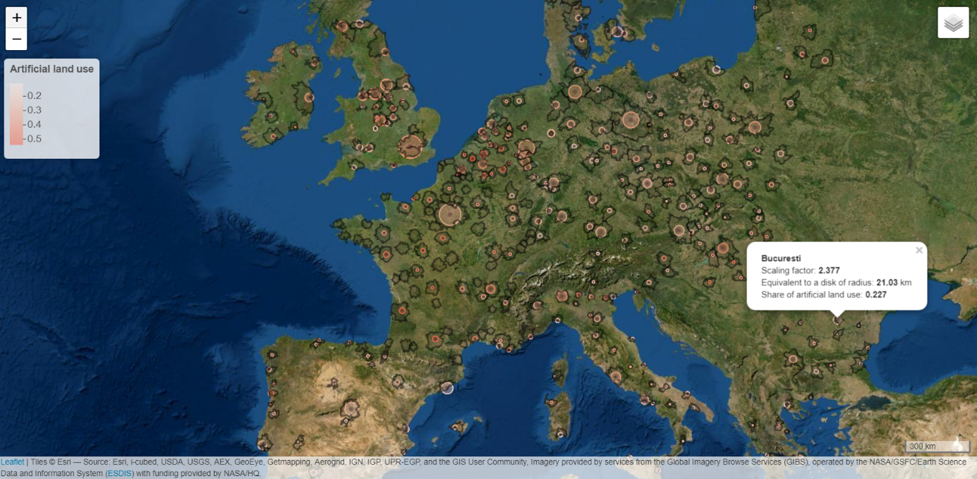

Figure 1. Estimate of the size of cities required to obtain a share of artificial land use found on average on a disc surrounding London by 70 km - Satelitte base map with FUAs displayed

1. **European examples**

This tab focuses on the graphic and cartographic representation of the rescaling of 4 typical cities with very different populations: Paris, Madrid, Bucharest and Innsbruck (figure 2). The evolution of the urban structure is analyzed from the distance to the main center.

For example, with urban scaling laws, Madrid gets a rescaling factor of 1.421. This means that Madrid has the same share of land artificialization at 21.11 km from its city hall as at 30 km from London's city hall ($\frac{30}{1.421}$).

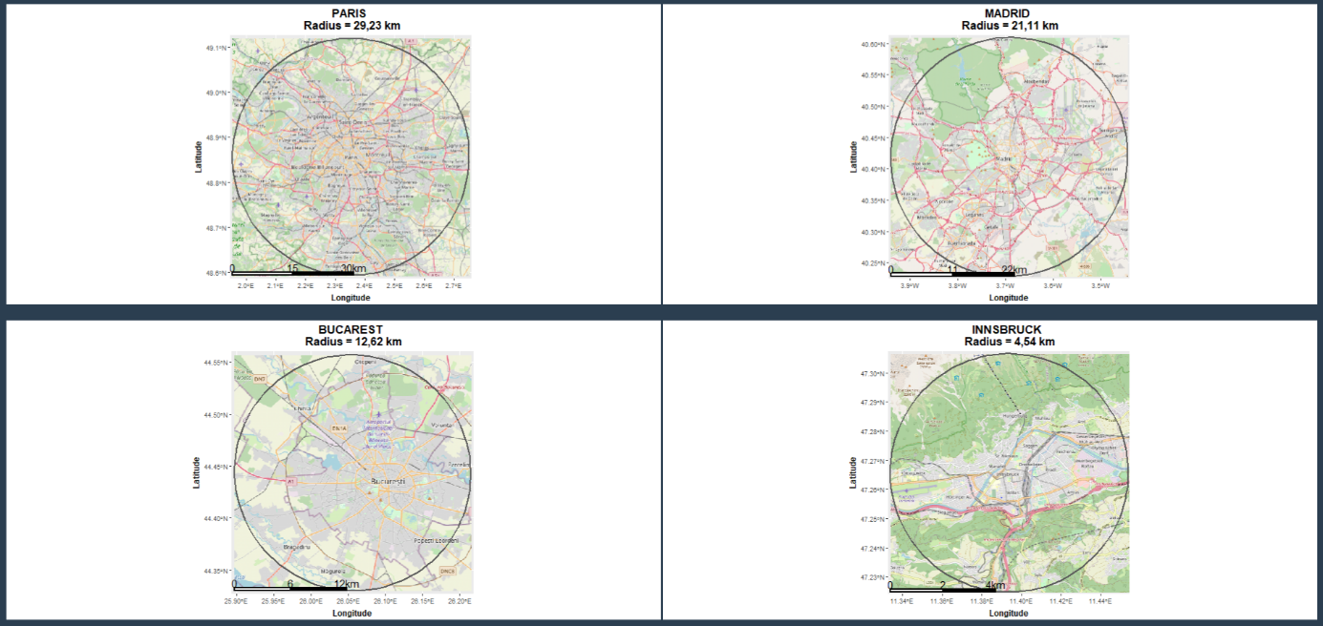

Figure 2. Artificial land use equivalent for a 30 km radius in London

According to the visual analyses, medium and smaller urban areas generally have higher levels of urban sprawl than larger ones after 20 km rescaled. Urban sprawl is more significant in smaller cities.

This page and the synthetic graph (figure 3) available in the application with the whole database shows that cities have a regular organization of the succession of land uses. For 80% of the database, the deviation in the share of land use change is at most 0.4 points for all 300 largest European cities. The fluctuations around the average are quite limited and are evenly distributed when comparing positive and negative deviations. So, can there be a change of practice towards a more sustainable management of land?

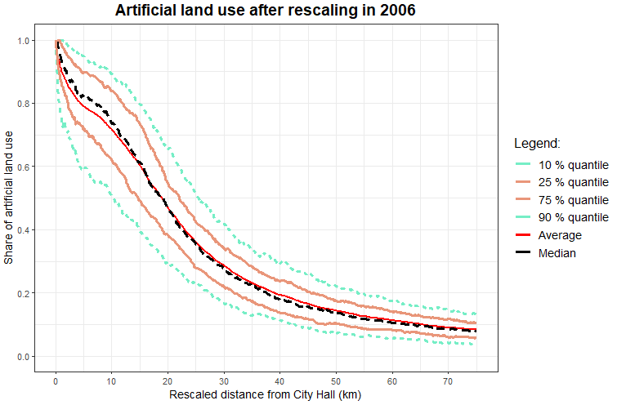

Figure 3. Synthetic representation of artificial land use after rescaling in 2006

1. **France versus Spain**

Urban scaling laws can't explain everything either: there are some cities that stand out, and some variations that appear at the margin. In particular, two large countries stand out compared to the average European city: French cities are more artificial than the average while Spanish cities are less (figure 4), more specifically in the first 10-30 kilometers (rescaled distance with London as reference). It is therefore interesting to study the differences in artificial land uses and to analyze which types of artificial spaces can be found in excess in France.

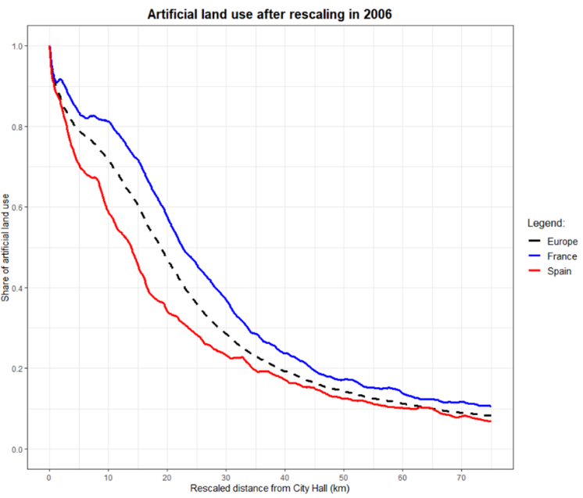

Figure 4. Artificial land use after rescaling in France and Spain, in 2006

First of all, it is mostly the proportion of urban fabric in France which is more important (after rescaling) than in Spain (figure 5).

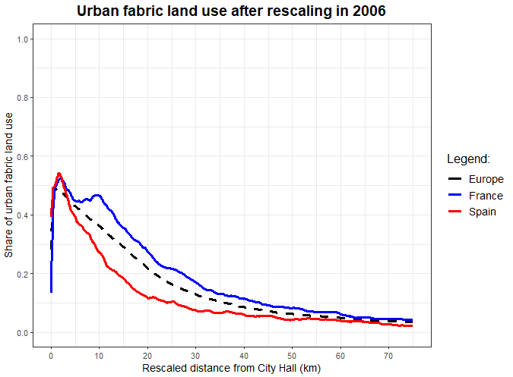

Figure 5. Urban fabric land use after rescaling in France and Spain, in 2006

In terms of land use for roads between France and Spain, the spatial evolution is quite similar, although France is slightly higher (figure 6). This is normal because the proportions of urban fabric and industries land use are more important in France, but the differences are smaller in relation to urban fabric land use, which means that in Spain there are more roads in comparison to available urban fabric than in France.

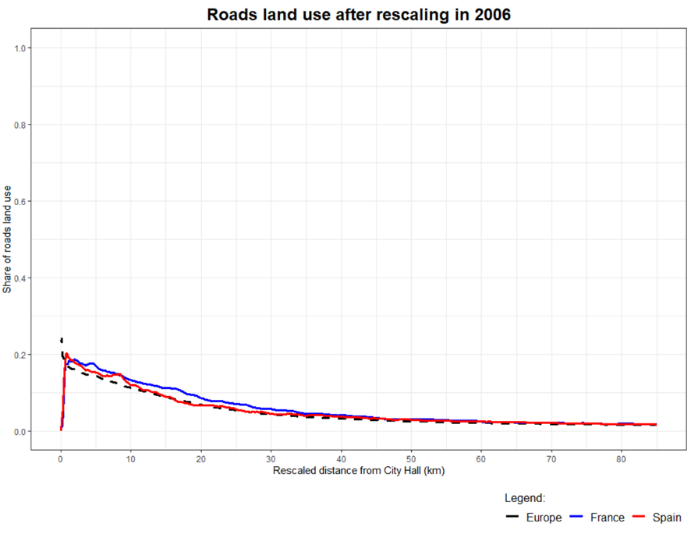

Figure 6. Roads land use after rescaling in France and Spain, in 2006

Urban contexts (topographical, historical and cultural effects) and planning policies are different between France and Spain, which explains some differences in artificialization. The urbanization in Spain contains more small compact clusters (Laborde, 1984) between agricultural lands, while in France at equivalent size (after controlling the size effect through rescaling) on observes more low-density peri-urban areas. In Spain, until 1960, urban development choices were made to the use the land already available within the cities and the construction of high buildings, which may explain why Spanish cities are more compact. Then, in order to cope with the arrival of new city dwellers, satellite cities were built near large metropolises (Diaz, 2007).

1. **And my city, how does it stand?**

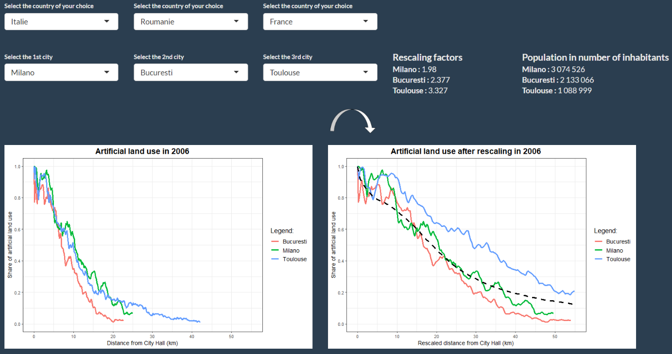The statistical and cartographic comparison of land use profiles between European cities allows each city to instantly situate itself in relation to the other selected cities in the database. A new point of view on the territory is thus possible through these tabs, and the visualization of the European average (black dotted line) is another point of reference for the comparison (figure 7).

Figure 7. Visualization of artificial land use in 2006 for 3 European lowland cities - User defined selection.

The maps have as advantages a better representation of the phenomenon of urban scaling laws. This web app, which can free us from the sizes of the cities, also allows us to compare urban forms while having the indication of the rescaled distance (with a slider to select the distance who adds even more freedom to the user in using the application) to the city center.

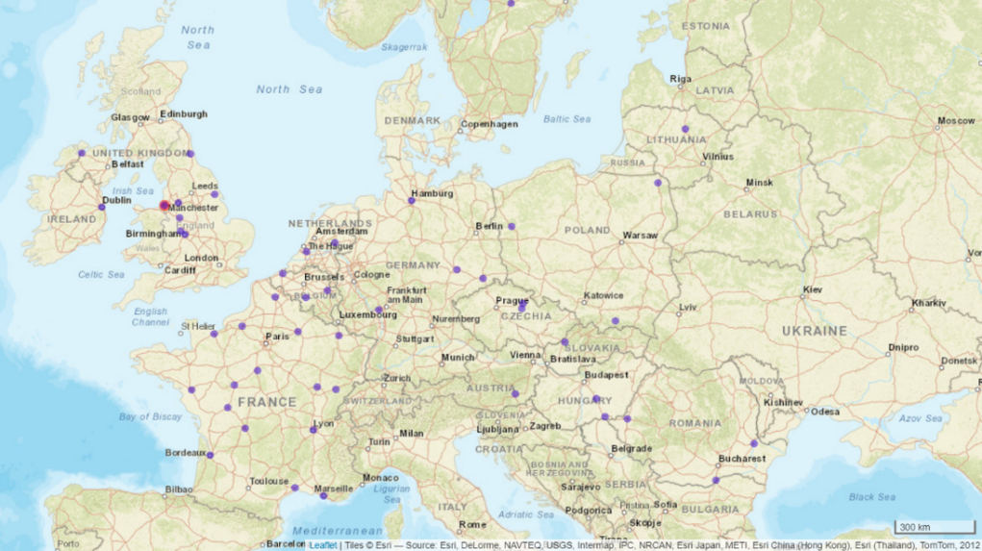The last tab aims to visualize the most similar European cities in terms of land use profiles according to the city chosen by the user (figure 8). The percentage of correlation and similarity between the cities desired by the user varies thanks to a slider (for a better intuitiveness). Thus, it is possible to compare a city with similar European cities other than the usual neighbors (which do not necessarily have adapted territorial contexts). It would be interesting to ask with which cities the actors of spatial planning are accustomed to compare themselves for the benchmarking of territorial actions?

Figure 8. European cities that are more than 95% similar in land use succession to Liverpool

1. **Interactive use**

The home map of the application (figure 9) is interactive by modifying the display with the zoom, by choosing the base map between the satellite view and the night light (which makes it possible to see the surface area of the urban areas), by loading additional layers with the French "Etablissements Publics de Coopération Intercommunale" / European FUA and by visualizing information with an information box that appears when clicking on each city.

The application offers a new look at European territories thanks to the rescaling.

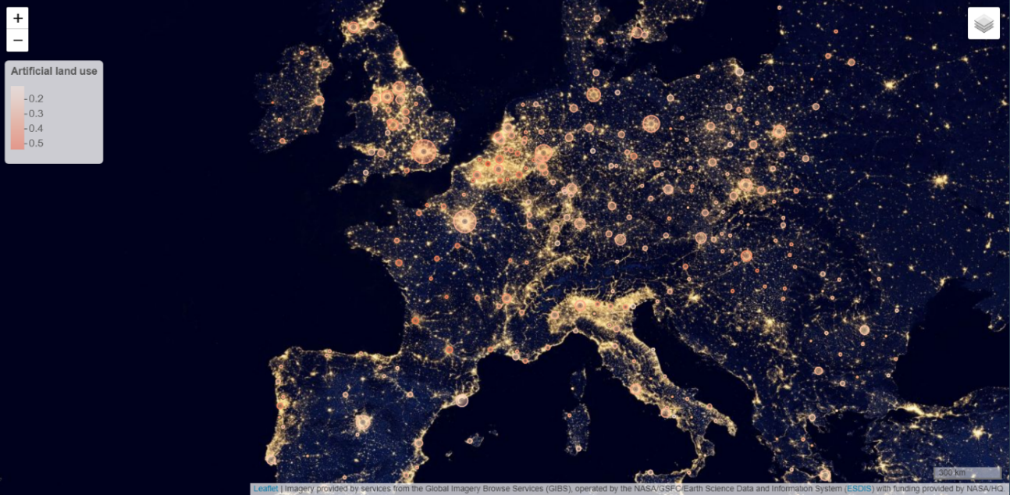

Figure 9. Estimate of the size of cities required to obtain a share of land artificialization found on average on a disc surrounding London by 50 km.

With this application, it is possible to compare several sizes of different cities (figure 10). For example, comparing Leicester to other similar European cities allows to put it in more than just a regional debate. This would be a useful way to evaluate urban planning strategies and in the implementation of public policies, by reusing for example actions that have been efficient in other similar cities (thanks to the strategic comparison of territories).

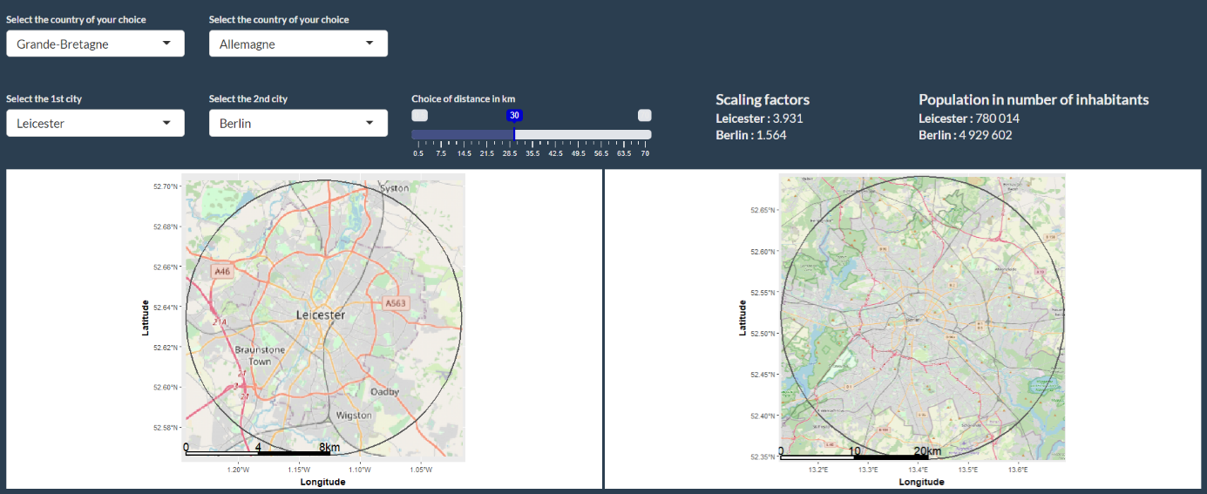

Figure 10. Comparison of land use shares with rescaled distances for Leicester and Berlin

And above all for spatial planning, it is important to situate the cities on a larger scale on urban sustainability and to compare cities with other European cities by analyzing how the size of the city and the internal form of urban development interact with each other.

1. **Explanation of results**

Overall, European cities are homothety in terms of land use profiles. Homothety is a mathematical transformation that multiplies all distances by a fixed factor while preserving shapes.

A significant proportion of large European urban areas are semi-natural. The use of artificial land for each city represents averages over two horizontal dimensions with the square root of city population.

The choice of a radial analysis is well suited to the general patterns of center-periphery organization of European cities, which have adapted their spatial organizations to the evolution of the modes of transport (Guérois M and Pumain D, 2008). The radial approach allows cities to be studied with a complete distribution of land and people using a reference center for each city. However, the radial approach smoothes out non-radial structures such as sub-centers nested within the urban structure, and it is also a problem for coastal cities and cities near each other.

Large urban areas have higher levels of urbanization and urban sprawl than small urban areas. The urban limits of land artificialization are therefore not equivalent for analyzing small and large cities, so the work of rescaling distances is essential to make them comparable and to have meaningful results.

Without rescaling, the decrease in artificial land shares is higher when the city has a smaller population. After rescaling distances from City Hall, European cities are positioned at similar levels on the issue of land use. Despite some fluctuations (figure 11) which are cities with different characteristics such as the presence of large natural areas, changes in altitude, historical and cultural aspects of urbanization, but also singular urban planning policies or it is due to border effects (missing data because the land is located after a certain distance in another country or city). Differences in urban morphologies and structures, such as elevation or the presence of water near the city center, can explain some of the differences between urban areas and the way a city develops.

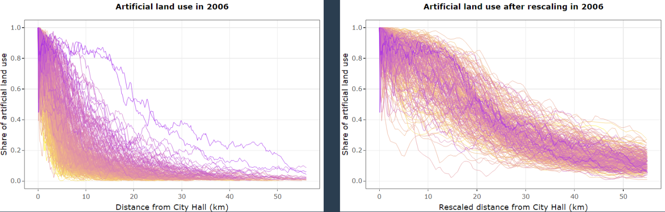

Figure 11. Shares of artificial land use for 305 European cities no rescaled and rescaled, the yellow curves represent the cities with the lowest populations and the purple cities are those with the highest populations.

There is a problem in the non-existence of a homogeneous definition in the literature of what is an urban area, and the lack of data in Urban Atlas for few cities. Data collection and the absence of a homogeneous definition of urban areas limits poses problems for the in-depth analysis of monocentric models (e.g., the fine distribution of the population if the delimitations are not the same in all countries).

The heterogeneity of land use is explained by distance effects from the center (radial effects), including transport costs and center-periphery developments, which have an impact on land use and population densities (Alonso model).

1. **Benefits of urban scaling laws for urban planning**

As we have seen, urban systems display regularities such as scale. So how can public policy intervention have an impact in defining and designing more appropriate urban forms?

Today, the operational issues of urban scaling laws are not sufficiently linked to theory. By crossing these two aspects, the objective is to analyze how the theory and the operational aspect can be enriched and integrated. There is not yet a defined methodology to support policy makers in managing land artificialization. For example, cities don’t know how to position themselves between them to know if they are very spatially spread out or not, but thanks to the laws of urban scale and the web application it is possible to make this strategic comparison of territories.

This tool will enable spatial planning actors to learn about scientific advances and the possibilities of urban scaling laws for their territories. It will also identify good and bad planning practices at national and European level. At the same time, they will see that there are other possibilities for urban development and planning that consume less space and are more environmentally sustainable. To deal with urban sprawl, densification, requalification of already built-up areas, and strict control of land are essential means to combat this phenomenon.

Currently, decision making is still too binary, either urban densification or urban sprawl, with unfortunately little mix between these two choices. But, the dichotomy between the dense city and the sprawling city is not very relevant for planning the cities of the future while welcoming new populations, preserving natural areas and responding to the problems of access to amenities. Thanks to the land use profiles, it is possible to see the areas where it is preferable to densify (e.g., where artificialization is above the European average) and on the contrary the areas where it is still possible to continue urban sprawl.

However, urban densification is not the only solution because it implies other issues. It is also necessary to increase the supply of housing, but also public transport, the supply of jobs, shops, urban green spaces, etc. The desire to increase densification and to move towards a compact city model should not make us forget that this remains a rather expensive economic model. Indeed, building near an urban center will always be more expensive than building on the outskirts. Creating public policies to increase the density of cities means expanding interactions between citizens, facilitating the interaction of distant individuals by decreasing transport costs and diversifying urban mobility. Should we favor the growth of large urban areas or the distribution of population in less populated areas? We need to have a good understanding of the mechanisms responsible for the observed behaviors before responding.

In the future, the aim will be to understand what makes the urban morphology of European cities homogeneous with rescaling distances, while the urban contexts and planning policies are different. For example, Rouen and Rennes (2 French urban areas with more than 500,000 inhabitants) have different urban morphologies but a 95.7% similar organization of land use successions (figure 12).

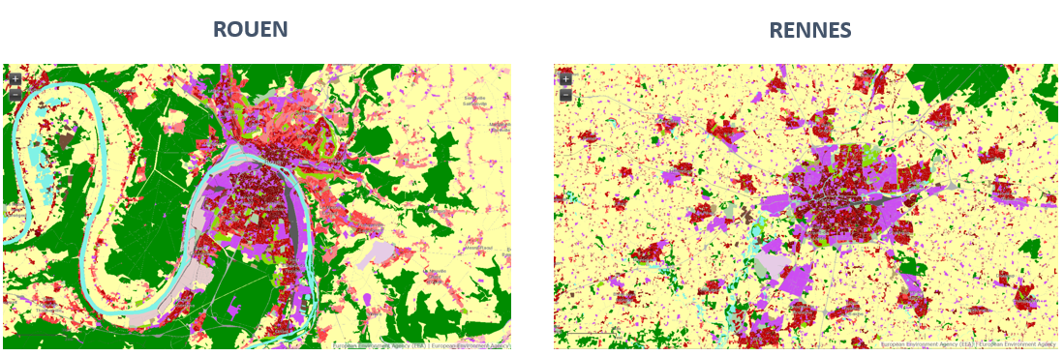

Figure 12. Land use types - Urban Atlas 2006

When we analyze cities in a relative way on the organization of land use successions, we observe that, overall, European cities have the same dynamics. Do the actors in the spatial planning of European cities all have the same thoughts on the construction and future of cities?

The European Commission would like that "ideally, cities should be able not only to assess their own situation, but also to compare themselves with other cities". So, thanks to this comparative geovisualization tool and the urban scaling laws, this is now possible.

This application is part of the European Commission's desire to achieve zero net land artificialization by 2050, at the European Union level. Each new artificialization will have to be compensated by a "renaturation" of unused artificial spaces. Thus, this work on the urban scaling laws is an important and primordial area of research to better understand the future challenges of urban densification.

**Conclusions**

The large corpus of cities to be treated and the objective of comparison on a European scale reinforces the relevance of the use of urban scaling laws. This analysis is relevant because urban sprawl has effects from the city center to the peripheral areas (more open, undeveloped space is available). This increased urban sprawl comes at a low economic cost but has a high environmental cost.

Visualization tools are useful to operationalize the use of scaling laws for managing and comparing cities, and to better understand this complex phenomenon. It has a significant development potential. For example, it can be optimized by updating the available data with the upgrade of the results (so the temporal evolutions will be visible), and by integrating population density data to make the link with artificial land use. But also, by retrieving data on a global scale to have a larger comparison and by dealing with other themes such as building height, commuting movements or land prices. Support for multiple languages would be a valuable addition for future versions. Some of the data is quite large, so it sometimes lacks a bit of fluidity in loading pages. But installing this application on a server would make it fully functional and operational for anyone.

Larger cities are larger in terms of area but are not more parsimonious in their land use per capita. The common radial structure of the European city presents people and activities distributed in a very heterogeneous way in the urban areas, with a big part dedicated to "natural" spaces.

So that empirical observation in and of itself, it lets us make certain predictions, on average, about what might happen as cities get larger. With the analysis of the temporal evolution of cities, informations on urban sprawl trends gleaned from other similar cities will be very useful for urban planning. With the assistance of this application, policymakers can better understand the effects of urban scaling laws in policy formulation. In a logic of increasingly rapid urban expansion, is there still a place for the imaginary question of the optimal size of the city?

The surprising homogeneity of land use patterns rescaled across Europe questions the real influence of highly differentiated planning principles and policies. The next step would be to have dynamic models that analyze the interactions between urban areas and specify how the dynamics of these interactions affect the final distribution after rescaling.

Urban planning must consider the balance between population densities, urban mobility and social interactions. In the longer term, it will therefore be a matter of questioning and carrying out policy actions in cities to promote economic development while living in attractive and decent places and protecting the environment. The urban scaling laws may be used in the future for areas other than land use, such as for the comparison of environmental or socio-economic outcomes of cities, which are essential for urban planning.

**References**

Batty M (2008) The Size, Scale, and Shape of Cities. *Science*, Vol. 319.

Batty M (2015) Competition in the Built Environment: Scaling Laws for Cities, Neighbourhoods and Buildings*. Nexus Network Journal* 17, 831-850.

Bettencourt LM (2013) The origins of scaling in cities. *Science*, 340(6139), 1438-1441.

Díaz, H. and al. (2007). Évolution du processus urbain espagnol dans la seconde moitié du XXe siècle. *Sud-Ouest européen*, tome 23, pp. 89-106.

European Environment Agency (2006). Urban sprawl in Europe: the ignored challenge. EAA Report, 10(2), 56.

European Environment Agency (2010) The European Environment: State and outlook.

Guérois M and Pumain D (2008) Built-up encroachment and the urban field: a comparison of forty European cities. *Environment and Planning A* 40(9), 2186-2203.

Keim D and al. (2008) Visual Analytics: Definition, Process and Challenges. *Information Visualization - Human-Centered Issues and Perspectives, Springer*, 154-175.

Laborde, P. (1984). Espaces ruraux et villes-centres en Espagne. *Revue géographique des Pyrénées et du Sud-Ouest*, tome 55, Péninsule Ibérique et Pyrénées, pp. 495-505

Lemoy R and Caruso G (2018) Evidence for the homothetic scaling of urban forms, *Environment and Planning B*.

Louf R and Barthélémy M (2014) Scaling: Lost in the Smog.

O'Brien O and Cheshire J (2016) Interactive mapping for large, open demographic data sets using familiar geographical features. *Journal of Maps*, 12:4, 676-683.

Pumain D and al. (2015) Multilevel comparison of large urban systems. *Cybergeo: European Journal of Geography, Systems, Modelling, Geostatistics*.

Rybski D, Arcaute E, Batty M (2019) Urban scaling laws. *Environment and Planning B: Urban Analytics and City Science*, 46(9).

Smith D (2017) Visualising world population density as an interactive multi-scale map using the global human settlement population layer. *Journal of Maps*, 13:1, 117-123.

Tobler W (1969) Satellite Confirmation of Settlement Size Coefficients.